Job Description

Job Title Māori Community Activator
Organisation Harbour Sport
Prepared February 2026
Location Sports House, Stadium Drive, Albany
Term Permanent, Full Time 40 Hours Week

Background

Auckland is a complex multi-cultural environment with many challenges, but also unparalleled opportunities to increase and sustain participation in regard to our target groups-children (tamariki) and young people (rangatahi) 5-18 years, particularly within low socio-economic areas; girls and young women aged 10-18 years; Māori, Indian, Samoan and Chinese ethnicities, in play, physical education, active recreation, and sport. This has led to the establishment of the strategic response known as The Auckland Approach to Community Sport, which contributes to the vision of Auckland being the world’s most active city.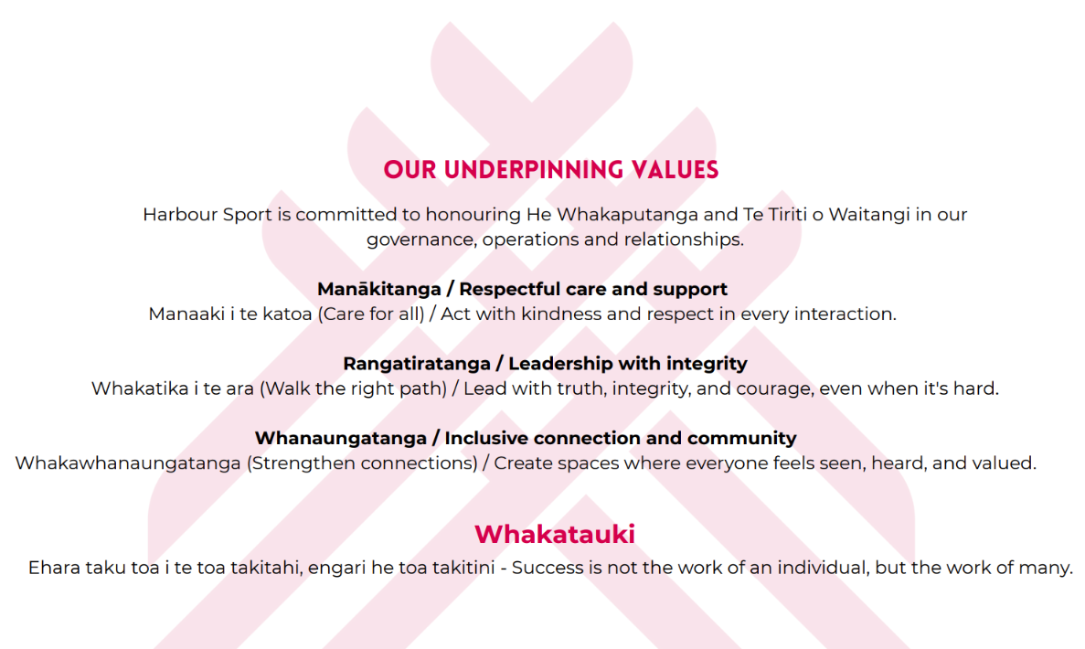

Job Purpose

Lead and deliver Te Oranga Kaiora sessions and cycle safety skills in kura kaupapa Māori and Māori community settings—creating culturally safe, engaging spaces where tamariki and rangatahi thrive through movement and connection. The role strengthens whanaungatanga with kura, whānau, iwi and hapū, and helps uplift cultural capability across Harbour Sport.

Key Areas of Role

Te Oranga Kaiora Delivery
- Deliver engaging, inclusive and culturally grounded Te Oranga Kaiora sessions that integrate Te Reo Māori, tikanga, Māori movement, games, and hauora principles.
- Create safe, uplifting environments where tamariki and rangatahi can build confidence, wellbeing, and identity through physical activity.
Cycle Safety Education
- Deliver cycle safety skills in kura and community settings using recognised safe riding practices.
- Support tamariki and rangatahi to develop confidence, awareness, and competence on bikes in both on-road and off-road environments.
Cultural Leadership & Facilitation
- Model Te Ao Māori practice through karakia, waiata, tikanga, and kawa appropriate to context.
- Use Te Reo Māori confidently and consistently in delivery, communication, and relationship building.
- Support Harbour Sport kaimahi through Te Ao Māori upskilling, wānanga, and practical cultural guidance.
Whanaungatanga & Partnerships
- Build and maintain strong relationships with kura kaupapa Māori, whānau, iwi, hapū, marae, and Māori community organisations.
- Strengthen partnerships that enable equitable access to kaupapa Māori movement programmes.
Programme Planning, Evaluation & Improvement
- Plan and prepare sessions, equipment, and venue logistics.
- Capture simple, meaningful data (attendance, engagement, feedback) to track progress and kōrero learnings.
- Reflect on and improve programme delivery to ensure quality and cultural safety.

Key Accountabilities

Quality Programme Delivery
- Consistent, high-quality delivery of Te Oranga Kaiora and cycle safety sessions.
- Sessions align to tikanga, kawa, safety requirements, and kaupapa Māori pedagogy.
Cultural Competency & Reo Māori Usage
- Demonstrate confident use of Te Reo Māori across settings.
- Uphold tikanga and promote safe, culturally appropriate behaviour within all programmes.
Tamariki & Rangatahi Engagement
- Build trusting, strengths-based relationships with young people.
- Ensure programmes are fun, engaging, accessible, and responsive to whānau needs.
Whānau, Kura & Community Relationships
- Maintain effective communication with kura leaders, whānau, and stakeholders.
- Ensure community partners feel valued, informed, and part of decision-making where appropriate.
Staff Cultural Development
- Provide regular guidance, tools, or wānanga to help build Harbour Sport staff confidence in Te Ao Māori.
- Act as a cultural enabler—not the sole cultural authority—within a supported organisational framework.
Reporting, Data & Safety
- Complete data collection, attendance, and basic evaluation in a timely manner.
- Ensure compliance with all safeguarding, health & safety, and delivery standards.
- Maintain up-to-date Police Vetting/Children’s Worker checks and First Aid.
Professional Conduct & Values Alignment
- Represent Harbour Sport positively in all interactions.
- Uphold rangatiratanga, manaakitanga and whanaungatanga at all times.

Relationships External

Establish and maintain effective relationships with key stakeholders including:
- Mana Whenua iwi
- Marae in the Region
- Urban Māori Authorities / Māori Service Providers
- Tertiary & Rangatahi Partners
- Sport NZ, Aktive, Other RST’s
- Auckland Council
- Local Boards
- National Sports Organisations (NSOs)
- Regional Sports Organisations (RSOs)
- Funding agencies and sponsors
- Sports Clubs
- Schools

Relationships Internal

- Harbour Sport Staff
- Harbour Sport Board
- Volunteers

Experience and Knowledge

Essential
- Te Reo Māori: Fluent or highly confident (kaupapa kōrero, facilitation, and written basics).
- Tikanga & kawa: Practical confidence operating in Māori spaces (kura, marae, iwi/hapū contexts).
- Youth engagement: Proven ability to connect with tamariki and rangatahi; strengths-based, fun, and inclusive facilitation.
- Programme delivery: Reliable, organised, and adaptable—able to plan and run sessions safely.
- Relationship building: Warm, authentic communicator who sustains partnerships with kura and community leaders.
- Data & reflection: Comfortable capturing attendance/feedback and writing short learnings to improve delivery.
- Values fit: Demonstrates rangatiratanga, manaakitanga, and a deep commitment to kaupapa Māori outcomes.
- Holder of a New Zealand Driving Licence

Desirable
- Cycle skills accreditation (e.g., Bike-skills instructor level) or willingness to attain within 3 months.
- Digital literacy: Confident with MS365/Teams, basic forms/surveys, and social media to connect whānau.
- Public speaking & facilitation: Comfortable leading assemblies/hui in both Te Reo Māori and English.
- Networking/sector know-how: Understanding of PARS ecosystem; able to navigate iwi/Māori organisations and kura networks.
- Creative thinking: Ability to design culturally resonant activities and resources.
- Previous experience of Sports Management, Sport Development, Organisation Capability Development ideally for in the Sport Sector
- Ability to coach, instruct and develop relationships with organisations
- High degree of energy, motivation and dedication
- Understanding of, and empathy with, people of different ages and cultures.
- Confidence in public speaking.
- Excellent oral and written communication skills.
- Team player
- Highly supportive of organisational values
- A person who values people within and outside the organisation
- Commitment to continuous improvement

Other Duties

This job description is a broad picture of the post at the date of preparation. It is not an exhaustive list of all possible duties and it is recognised that jobs change and evolve over time. Consequently, this is not a contractual document, and the post holder will be required to carry out any other duties to the equivalent level that are necessary to fulfil the purpose of the job.

